This is for u know who
Description
Someone from the Hogwarts send this file given below to the voldemort.I don’t know who it is and what is the information in it. What ever the information is but it will definitely harm harry so find the person who send it. The flag lies there.

--I USED “exiftool” COMMAND FOR FINDING ANY COMMENTS OR META DATA
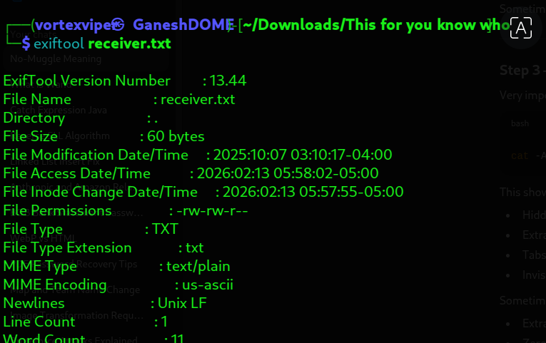

--xxd converts any file into hexadecimal representation
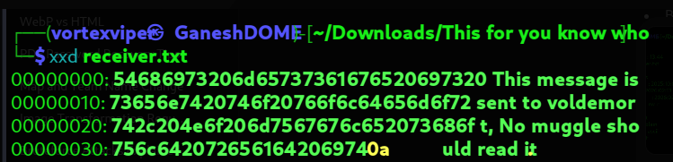

0a represents nxt line

--listing hidden files
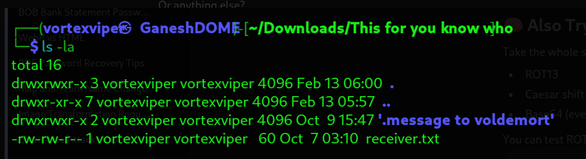

As txt file contains no muggle should read it
Found one file which is .message to voldermort
Inside .file we get top_secret.png file

--To extract the data present in topsecret I have done binwalk
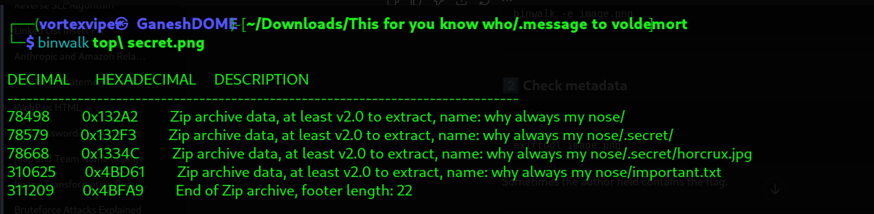
Unzipped manually and got horcrux.jpg

After I used binwalk to get embedded files and also I have used steghide but no use after I got with exiftool

--Used exiftool to get artist or comment ot metadata
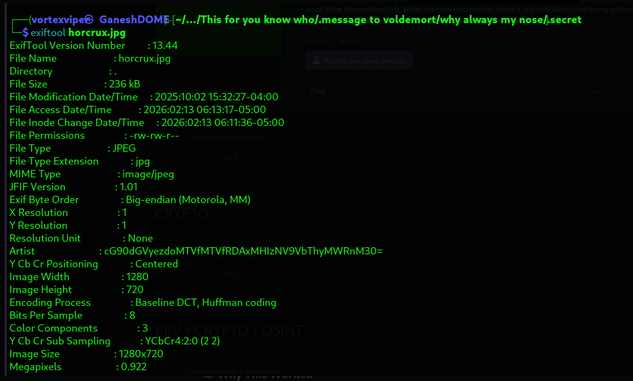
I have got an artist which is encoded in 64 bit

After decoding it I have got the flag.

